Spectral Analysis of the Pi Mensae System
  - Luke Hyndman - 32098455

Abstract
Stars hosting transiting exoplanets provide valuable insights for studying planetary formation. Spectroscopic analysis of exoplanet host stars and the atmospheres of exoplanets is one of the few methods available to gather information about planets beyond our solar system. Understanding the types of stars around which planets form and their formation processes can inform our knowledge of stellar and planetary systems, including our own. The Pi Mensae system, which hosts the transiting Super-Earth Pi Mensae c, offers such an opportunity. This investigation measured the radial velocity of Pi Mensae and used synthetic spectra to fit its metallicity, effective temperature, and surface gravity. Additionally, transit spectroscopy was attempted on Pi Mensae c. The radial velocity of Pi Mensae was successfully determined to be (103 ± 6) × 10^2 m/s. However, Pi Mensae’s stellar parameters were incorrectly determined due to issues with normalising the observed spectrum during reduction. The attempted transmission spectroscopy of Pi Mensae c was also unsuccessful, with no clear absorption lines detected. The next steps in this investigation include capturing additional spectra of Pi Mensae c in and out of transit to improve the signal-to-noise ratio and renormalising Pi Mensae’s spectrum to achieve a correct fit for its stellar parameters. Finally, determining a automatable method for searching the data for absorption spikes would speed up future analysis of transmission spectra.

Introduction

Aim and Overview
This investigation aims to measure the radial velocity and stellar parameters of the G-dwarf star and exoplanet host Pi Mensae. Namely, its metallicity, effective temperature, and its surface gravity. Additionally, it aims to perform transit spectroscopy on the exoplanet Pi Mensae c with the hope of identifying absorption lines in the optical band. Previous studies have attempted to find H₂ in Pi Mensae c’s atmosphere but were unable to [1].

2.2 Exoplanetary Systems
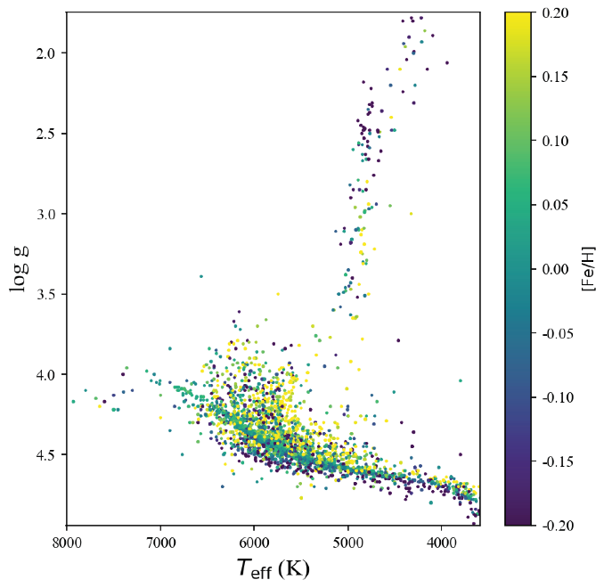
Exoplanetary systems are a key point of investigation for researchers hoping to understand how our solar system formed. Systems with planets that transit are of particular interest as transit spectroscopy provides insight into the compositions of planetary atmospheres. Exoplanet hosts can help us understand our own sun. Additionally, gathering data on exoplanet hosts can inform us on which kinds of stars are likely to host planets. Figure 2.1.1 shows the distribution of exoplanet hosts in terms of the 3 main stellar parameters. We see the main sequence stars with surface gravities greater than 4.0. Stretching upward from the main sequence, we see the red giants. Also, note that there are no host stars below a metallicity of -0.2. This is to be expected, as metals are required for planet formation. By studying the stellar properties of exoplanetary systems, we can increase our understanding of when, where, and how planets form around stars. The other reason for interest in exoplanets is to further the search for habitable worlds beyond our own, should we need to leave Earth in the distant future.
[Figure 2.1.1]: Distribution of Exoplanet hosts by stellar parameters [2]

2.3 Stellar Spectroscopy
Spectroscopy allows astronomers to discern a vast amount of information about a star with a single measurement. Line broadening indicates the surface gravity of the star. Hotter stars will emit more at shorter wavelengths. The intensity of the lines implies the metallicity of the star. These 3 parameters alone can describe almost every star type. This investigation intends to add to the growing amount of data associated with exoplanet hosts and their parameters by using synthetic spectra to fit these 3 parameters.

2.4 Transmission Spectroscopy
Exoplanets whose orbits cause them to transit between their star and Earth present a unique opportunity to study their atmospheres using spectroscopy. During a transit, the star's light passes through the planet’s atmosphere. By comparing the spectrum observed during transit to that observed outside of transit, a transmission spectrum of the planet’s atmosphere can be obtained. This method provides crucial insights into the planet’s composition, thermal profile, and potential habitability, offering clues about its formation and evolutionary history. This approach is precious for studying exoplanets that differ from those in our solar system. Planets best suited to this are those with dense atmospheres and deep transit depths. Transit depth is a parts-per-thousand measurement of the fraction of how much light from the star is being occluded during the transit. This investigation is primarily concerned with the content of a planet’s atmosphere. Thus, this project intends to search for absorption lines in Pi Mensae c’s optical transmission spectrum.

2.5 Target Selection - Why Pi Mensae?
There are many transiting exoplanets visible from UCMJO, Pi Mensae was selected from them as the target for this investigation for several reasons. Namely, its bright apparent magnitude of 5.7 [3], its visibility during the observing window between 24/8/24 and 2/8/24 [4], and its short orbital period allowing two chances to capture the transit during the observing window. These combined factors made it the strongest candidate to undergo stellar and transit spectroscopy with the UCMJO McLellan 1m telescope. However, despite being the best target for the goals of this investigation, it still lacks in several key categories. Notably, Pi Mensae c’s short orbital period. While it is convenient for capturing multiple transits over different days, this brief period comes at the cost of being very near its host star. Pi Mensae c orbits at approximately 0.02 AU [5]. Pi Mensae c is a rocky Super-Earth, and therefore has a small planetary radius. This leads to the planet having a transit depth of only 0.32ppt. The other problem presented by this combination of nearby orbit and small size is that Pi Mensae c likely has little to no atmosphere due to atmospheric escape caused by the proximity to its star [6]. These factors put the transmission spectroscopy part of this investigation on the margins of feasibility. Other targets with deeper transit depths were considered but none orbited stars bright enough for the McLellan 1m. Nevertheless, transit spectroscopy was still attempted. This motivated the focus of this investigation to be primarily on the host star’s parameters rather than the planet’s transmission spectrum.

3. Method

3.1 Observation
Pi Mensae was observed with the UCMJO McLellan 1m Telescope. 6 30-minute exposures were taken across 5 nights. 5 of the 6 exposures were completed but 1 had to be aborted due to rain. This left 3 exposures of the transiting planet and 2 of the host star. To assist with the reduction process, 5-second thorium-argon lamp exposures were taken hourly. 10 1.7-second white exposures were also taken nightly.

3.2 Reduction
The data was reduced in the following stages:
- The raw spectral images underwent bias subtraction using a bias strip to eliminate noise. See an example raw image in figure 3.2.1
- Then, master whites were synthesized by taking the median value of each white exposure. See an example white image in figure 3.2.2
- The master whites were used to trace the positions of the orders within the raw images.
- To convert the orders from pixel space to wavelength space, the thorium exposures were used with a thorium atlas. See an example thorium exposure in figure 3.2.3
- Each order was then normalised using a continuum fit.
- Finally, the orders were combined into one spectrum, being averaged in overlapping regions.
The reduced spectra of the star and planet were each interpolated onto a template wavelength. They were then combined by taking their median values to obtain single spectra of both the transiting planet and the star.
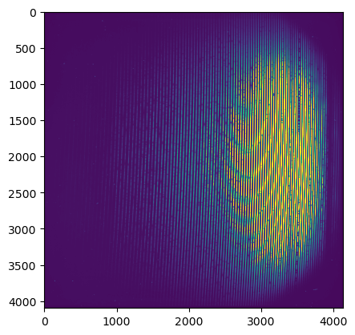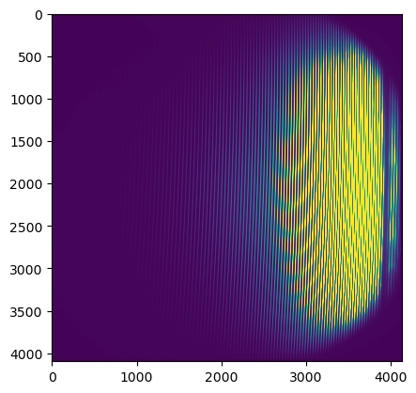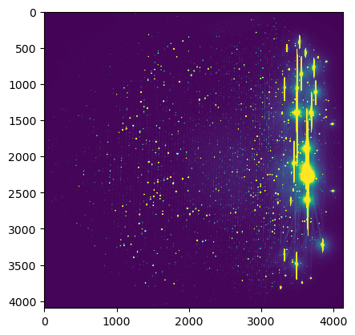
[Figure 3.2.1]: Raw Image [Figure 3.2.2]: White Image [Figure 3.2.3]: Thorium-Argon Image

3.3 Radial Velocity
To calculate the radial velocity of Pi Mensae, known positions of 62 strong Iron lines were obtained from NIST’s line list [7] and were used with a Gaussian fit to calibrate the shift in wavelength of the star’s spectrum. This shift in wavelength was used with the Doppler shift equation to solve for the star’s radial velocity. The spectra were then shifted to their correct wavelength. Figure 3.3.1 shows the shift in strong Fe line positions used to calculate radial velocity. Iron lines were chosen for their tall and narrow peaks that are easy to find the centre of
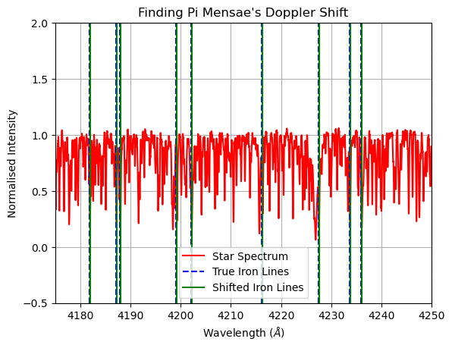
[Figure 3.3.1]: Shifting of Strong Fe lines in Pi Mensae’s observed spectrum

3.4 Transmission Spectrum
To obtain the transmission spectrum of Pi Mensae c, the master transit spectrum was subtracted from the master stellar spectrum. This gave the planets transmission spectrum. The spectrum was then inspected for absorption lines, which indicate the presence of gasses within Pi Mensae c’s atmosphere. See the in and out of transit spectra in figure 3.4.1.
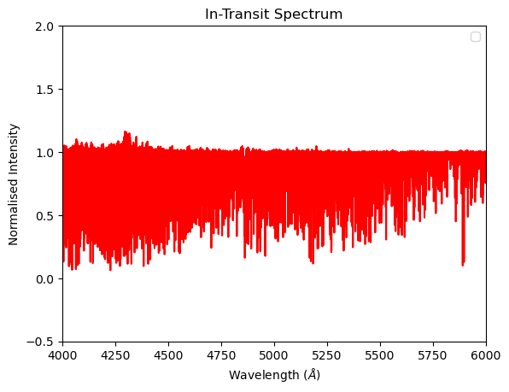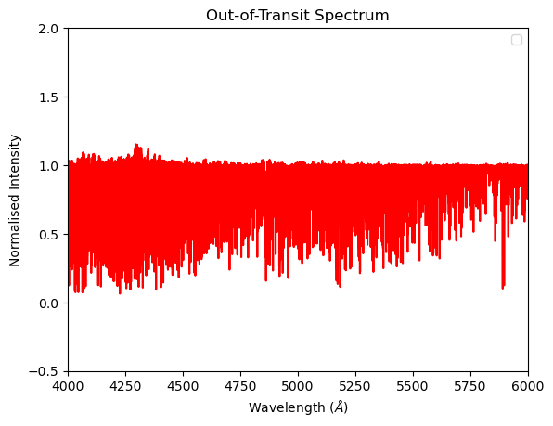
[Figure 3.4.1]: Pi Mensae’s in and out of transit spectra

3.5 Stellar Parameters
To fit stellar parameters, high-quality synthetic spectra were needed. To save time, literature values for Pi Mensae’s parameters [8] were used to acquire 123 synthetic spectra from the POLLUX database [9]. By selecting only spectra with parameters within a range of the true known ones, much computing time was saved. The spectra were all interpolated onto the same wavelength as Pi Mensae’s spectrum and were clipped to be between 500nm and 550nm to eliminate telluric noise. The same wavelength clipping was done to Pi Mensae’s spectrum. Every synthetic spectrum underwent a $χ^{2}$ fit with the real spectrum. The parameters of the best-fitting spectrum were then extracted from the file header.

4. Results

4.1 Radial Velocity
Pi Mensae’s radial velocity was found to be $\left(103 ±6\right)× {10}^{2} ms^{-1}$. This figure agrees with the literature [8]. The uncertainty was obtained from the standard deviation of velocities calculated from individual line shifts.

4.2 Transmission Spectrum
Aside from a single aurora line 557.7nm, an undiagnosable line at 516.9nm and a likely telluric triplet at 591.9nm, there were no obvious features detected in the transmission spectrum. See [FIGURE]. The spectrum has been clipped to leave out telluric noise.
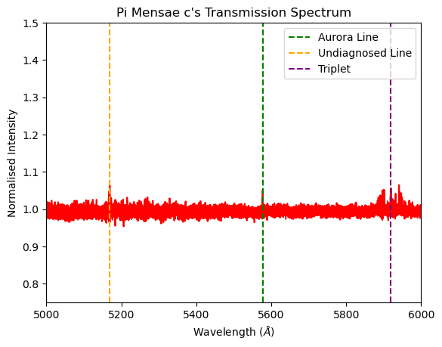
[Figure 4.2.1]: Pi Mensae c’s transmission spectrum. Note that there are very few features. Triplet is likely telluric. Note that increases intensity represent absorption.

4.3 Stellar Parameters
The best fit had a chi squared value of 150.89. The corresponding parameters were:
    - Surface gravity $\log{g}=\text{ 5.00}±0.5 \text{cm }s^{-2}$
    - Effective temperature $T_{eff}=5750 ±125 K$
    - Metallicity $Z \left[\frac{Fe}{H}\right]=-1.00±0.25$
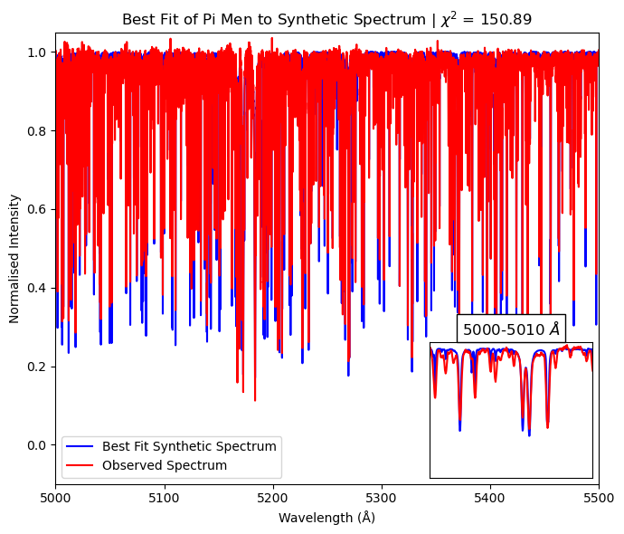
[Figure 4.3.1]: Best fitting synthetic spectrum compared to observed spectrum of Pi Mensae.
The best fitting spectrum is shown in figure 4.3.1. The uncertainties come from the step in each parameter between different synthetic spectra. The parameters of best fit do not agree with literature values. Literature values are closer to:
    - $\log{g}=\text{ 4.4}\text{0}\text{ cm }s^{-2}$
    - $T_{eff}=6000 K$
    - $Z \left[\frac{Fe}{H}\right]=0.10$
The fit of the nearest parameter synthetic spectrum is shown in figure 4.3.2.
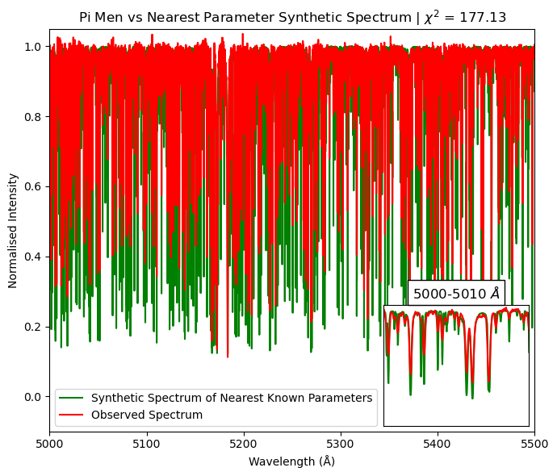
[Figure 4.3.2]: The fit of Pi Mensae’s observed spectrum to the synthetic spectrum with parameters closest to literature values.

5. Discussion and Next Steps

5.1 Radial Velocity
The calculated radial velocity value of $\left(103 ±6\right)× {10}^{2} ms^{-1}$ agrees with literature values [8].

5.2 Transmission Spectrum
The reduced transmission was largely noise. The only notable features were an aurora line which does coincide with auroral activity on the night of the observation of the transit. There is also a triplet of lines at 557.7nm that is likely telluric by the shape of the lines within the triplet. There was another line at 516.9nm that also could not be diagnosed as no corresponding wavelength line could be found in NIST’s line list.
The null result transmission spectrum is unfortunate but not entirely unexpected. There are several factors that could have contributed to this result. As mentioned, because Pi Mensae c orbits within 0.02 AU of Pi Mensae [5], it only has a transit depth of 0.32 parts per thousand. Furthermore, this close orbit is likely resulting in atmospheric escape on the planet leading to there being little to no atmosphere to absorb light in the first place [6]. This result indicates that Pi Mensae has little to no atmosphere.
However, there are several avenues that could be explored to successfully perform transit spectroscopy with the McLellan 1m. Firstly, selecting a target with a deeper transit depth would likely improve the signal-to-noise ratio (SNR) of the captured spectra. Secondly, the seeing conditions on the nights of observation were not entirely optimal. More exposures under better conditions would also contribute to improving the result. An ideal target would be a large hot Jupiter orbiting near a bright apparent magnitude star near to the celestial south pole. This would ensure that the star and its planet would be visible most of the time, with deep transits occurring regularly. Most of these factors were included when picking Pi Mensae c as a target aside from the transit depth. Also, it should be noted that there was no concrete method for searching the spectrum for lines. In future, it would be wise to devise a hardcoded method to search for peaks. Such a method could rely on an imported list of strong lines.

5.3 Stellar Parameters
The parameters of best fit do not agree with the literature values [8]. We see that the observed spectrum should fit best to the following parameters but doesn’t [figures 4.3.1, 4.3.2]. This is likely due to a problem with the reduction process. Specifically, with the continuum fit done by MEGARA to normalise the spectrum. When the continuum is fit with a polynomial, the fitting can be too aggressive, causing the wrong polynomial to be selected and the spectrum to be slightly ‘squashed’ vertically. This squashing has not happened to the synthetic spectra obtained from POLLUX. This is why we see that even the best fit is relatively far off. To combat this, locking individual parameters to their correct values and fitting for the other two was attempted. This was also unsuccessful as temperature and metallicity have inverse effects on the spectrum, causing a compensatory effect where if the correct temperature was fit, then the metallicity would be more incorrect and vice versa. In future this issue could be addressed by renormalising the observed spectrum to the synthetic ones. However, this required time and coding prowess beyond the scope of this project.

6. Conclusion
To conclude, spectral analysis was done on Pi Mensae and its second planet Pi Mensae c, with the aim of determining Pi Men’s radial velocity, metallicity, effective temperature, and surface gravity. And, to investigate the presence of gases within Pi Mensae c’s atmosphere. The radial velocity was found to be $\left(103 ±6\right)× {10}^{2} ms^{-1}$. This radial velocity value agrees with the literature. The transmission spectrum of Pi Mensae c was largely empty indicating either little to no atmosphere on the planet or a weak SNR due to low transit depth. This result helps to inform us on what kinds of targets should be selected when looking to perform transit spectroscopy. The stellar parameters retrieved from fitting synthetic spectra were in close to the correct values but not completely correct. This incorrect best fit is a result of issues with the normalisation of the observed spectrum during the reduction. The next steps for this investigation would be to capture more transit spectra (ideally as many as possible) to decrease the SNR of the data and to renormalise the observed spectrum to correctly align with the synthetic spectra.

7. References
- Garcia Munoz, A., et al., 2019, “Is π Men c’s Atmosphere Hydrogen-dominated? Insights from a Non-detection of H I Lyα Absorption”, The Astrophysical Journal Letters, Volume 888, Issue 2, L21, 12 pp, arXiv:1912.06913
- Yanke, T., et al., 2024, “The Statistical Analysis of Exoplanet and Host Stars Based on Multi-Satellite Data Observations”, Universe 2024, 10, 182. https://doi.org/10.3390/universe10040182
- Johnson, H. L., et al., 1966, “UBVRIJKL Photometry of the Bright Stars”, Communications of the Lunar and Planetary Laboratory, Volume 4, Part 1, p.99-110, Bibcode: 1966CoLPL...4...99J
- Jensen E. L. N. 2013. Tapir: A Web Interface for Transit/Eclipse Observability, Astrophysics Source Code Library ascl:1306.007.
- Huang, C. X., et al. 2018, “TESS Discovery of a Transiting Super-Earth in the pi Mensae System”, Astrophysical Journal Letters, 868, L39, doi:10.3847/2041-8213/aaef91
- King, G., et al. 2019, “The XUV irradiation and likely atmospheric escape of the super-Earth π Men c”, MNRAS Letters, 484, L49, doi: https://doi.org/10.1093/mnrasl/slz003
- National Institute of Standards and Technology (NIST). (n.d.). NIST Atomic Spectra Database. Retrieved October 22, 2024, from https://physics.nist.gov/PhysRefData/ASD/lines_form.html
- SIMBAD. Pi Mensae: SIMBAD Astronomical Database. Retrieved October 22, 2024, from https://simbad.u-strasbg.fr/simbad/sim-id?Ident=pi+Mensae
- AMBRE : de Laverny, P., et al., 2012, A& A 544, A126, from https://pollux.oreme.org/collections/

